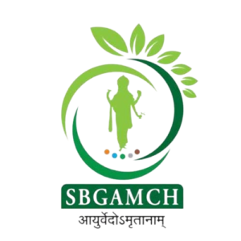
DBAET'S

SBG Ayurvedic Medical College & Hospital Belagavi
Laxmi Tekadi, Ganeshpur Road, Opp Federal Bank Belagavi, Karnataka India.
+91 8277937770 , 0831-2447771
Department Wise IP Report Between 01.11.2024 and 30.11.2024

SL NO | DEPARTMENT NAME | NO.OF NEW PATIENTS VISITED
1 | VISHACHIKITSA | 1
2 | KAYA CHIKITSA | 43
3 | SHALYA TANTRA | 29
4 | SHALAKYA TANTRA | 34
5 | PRASOOTI TANTRA | 34
6 | KAUMARA BRUTYA | 30
7 | PANCHAKARMA | 48
 | Total | 219

